Tool | Primary Purpose | Category | Platforms | Typical Use Cases | Download / Source | Strengths | Limitations
NetExec | Test and enumerate Windows networks and Active Directory environments | Active Directory / Network Testing | Linux, Windows | AD enumeration, SMB testing, account, and share testing | GitHub | Fast, useful for AD assessments, supports multiple network services | Requires networking and AD knowledge and careful use to avoid security risks.
BloodHound | Identify relationships and possible attack paths in Active Directory | AD / Attack Path Analysis | Windows, Linux, macOS | Finding privilege paths, analyzing AD relationships, security audits | GitHub | Visual and easy to understand, useful for red and blue teams | Requires AD data, can be complex for beginners
Impacket | Work with network protocols and Windows authentication | Network / AD Testing | Windows, Linux, macOS | SMB testing, AD testing, protocol analysis, security research | GitHub | Large collection of tools, supports many protocols | Requires networking knowledge and can be complex
Responder | Test Windows network authentication and name-resolution security | Network / Credential Testing | Linux | Testing authentication security, security assessments, identifying weak configurations | GitHub | Useful for finding authentication weaknesses | Can expose sensitive information and affect network traffic
Mimikatz | Test Windows authentication and credential security | Credential Testing | Windows | Authentication testing, credential security research, penetration testing | GitHub | Powerful Windows security testing tool | Can expose sensitive credentials and may be detected by security software
Hashcat | Audit and recover passwords from password hashes | Password Auditing | Windows, Linux, macOS | Password testing, password recovery, hash auditing | GitHub | Very fast, supports many hash types, can use GPUs | Some passwords can take a long time to recover; require computing resources
Metasploit Framework | Test vulnerabilities and security controls | Vulnerability Assessment / Exploitation | Windows, Linux, macOS | Penetration testing, vulnerability testing, security research | GitHub | Large number of modules, widely used, useful for learning | It can be dangerous if misused and requires security knowledge
PsExec | Run processes remotely on Windows systems | Remote Administration / Windows Security | Windows | Remote administration, troubleshooting, security testing | Microsoft Sysinternals | Lightweight, easy to use, official Microsoft tool | Requires proper permissions and can be abused for unauthorized access
mitm6 | Test IPv6 security weaknesses in Windows networks | Network / IPv6 Security | Linux | IPv6 security testing, Windows network assessments | GitHub | Useful for identifying IPv6 configuration weaknesses | Requires networking knowledge and can interfere with network traffic
Sublist3r | Find subdomains of a target domain | Reconnaissance / OSINT | Windows, Linux, macOS | Subdomain enumeration, reconnaissance, penetration testing | GitHub | Simple, useful during reconnaissance, uses public sources | Older project, some sources may no longer work
The following toolkit below contains my top ten cybersecurity tools that can be use in ethical hacking, penetration testing, and security analysts.
For this section 2 comparison, I chose NetExec, Responder, and Mimikatz. All these tools are extremely useful for penetration testing and Windows security assessments. But each tool focusses on different part of the security testing.
Similarities
NetExec, Responder, and Mimikatz mostly use Windows network security testing and identify weaknesses in system by ethical hackers or penetration testers. These tools are especially useful to understand the attack methods or how attackers can take advantage of vulnerable system and authentication problems. For security end, security professionals can use these tools for their knowledge. With these tools, security professionals can identify security weaknesses and improve their defenses to protect sensitive information. All three of these tools should be use in system testing where testing is fully authorized.
Differences
NetExec: To evaluate Windows networks and Active Directory environments, NetExec is the one of best options to choose. It can be use for gathering information about systems, password spraying against protocols like SMB, WinRM, LDAP, and MSSQL, and assess account access.
Responder: It is main use for testing network name-resolution and authentication security. It used to find weaknesses in Windows system, also it can help to identify how windows system response on certain network requests. Besides that, with this tool security professional can bump hashes of every account or system that connected to the network.
Mimikatz: This is immensely powerful tool for testing Windows authentication and credential security. It is commonly use for authorization security testing and to study how windows can expose important credential and authentication information.
Advantages and Disadvantages
Tool | Advantages | Disadvantages
NetExec | It is very quicky gather information from Windows networks. It is highly favored by penetration testers and red teams for its speed, flexibility, and extensive feature set | Main disadvantage of this tool is High Network Noise. Also, this tool may cause Active Directory account lockouts if misconfigured
Responder | It helps to identify weaknesses in network authentication. Also, it is especially useful to test Windows network security. | If it is not use properly, it can disrupt the network traffic. It also can leak sensitive authentication information. Requires legacy protocols like LLMNR or NBT-NS to be enabled for certain attacks to work.
Mimikatz | It can be useful to see how Windows stores and manages authentication credentials. Besides that, useful to testing is Windows can protect sensitive authentication information. | Requires heavy modification to evade defenses. Also, easily detected or blocked by security software.

When Each Tool Is Most Useful
I would use Responder to bump hashes from network. For example, when any user who is connected to the network and log in to windows system the Responder immediately dumps hashes and username of that windows system. And these hashes can be used to analyze or crack to get the plaintext passwords. And from a security perspective, this helps organization to make sure that everyone is using Stronge passwords. I would use NetExec to spray dump hashes, passwords, or common passwords out on the internet against protocols like SMB, WinRM, LDAP, and MSSQL. Also, I would use this tool to gather information regarding Windows networks. If I am doing penetration testing, then I will use Mimikatz. After having credentials, I try to spawn of the system and turn off the windows defender or any anti-viruses. After that, I will install Mimikatz and use that one to find out what sensitive information that can leak by Windows security, later, I can fix those leaks.
User Handbook: NetExec (NXC)
Purpose: NetExec is a network security testing tool used for Windows network and Active Directory environment. It allows security professionals to check network services and review security settings.
Intended Audience: Ethical hackers, penetration testers, and security analysts.
Common Cybersecurity Applications:
- Testing Windows network security.
- Reviewing SMB services.
- Checking Active Directory security.
- Identifying possible access and configuration weaknesses.
Installation
System Requirements
- Kali Linux or another supported Linux system.
- Internet connection for installation.
- Sufficient disk space for the tool and its dependencies.
- Permission to perform security testing in an authorized lab.

Installation Steps
- Open the Kali Linux terminal.
- Update the package list.
-- sudo apt update
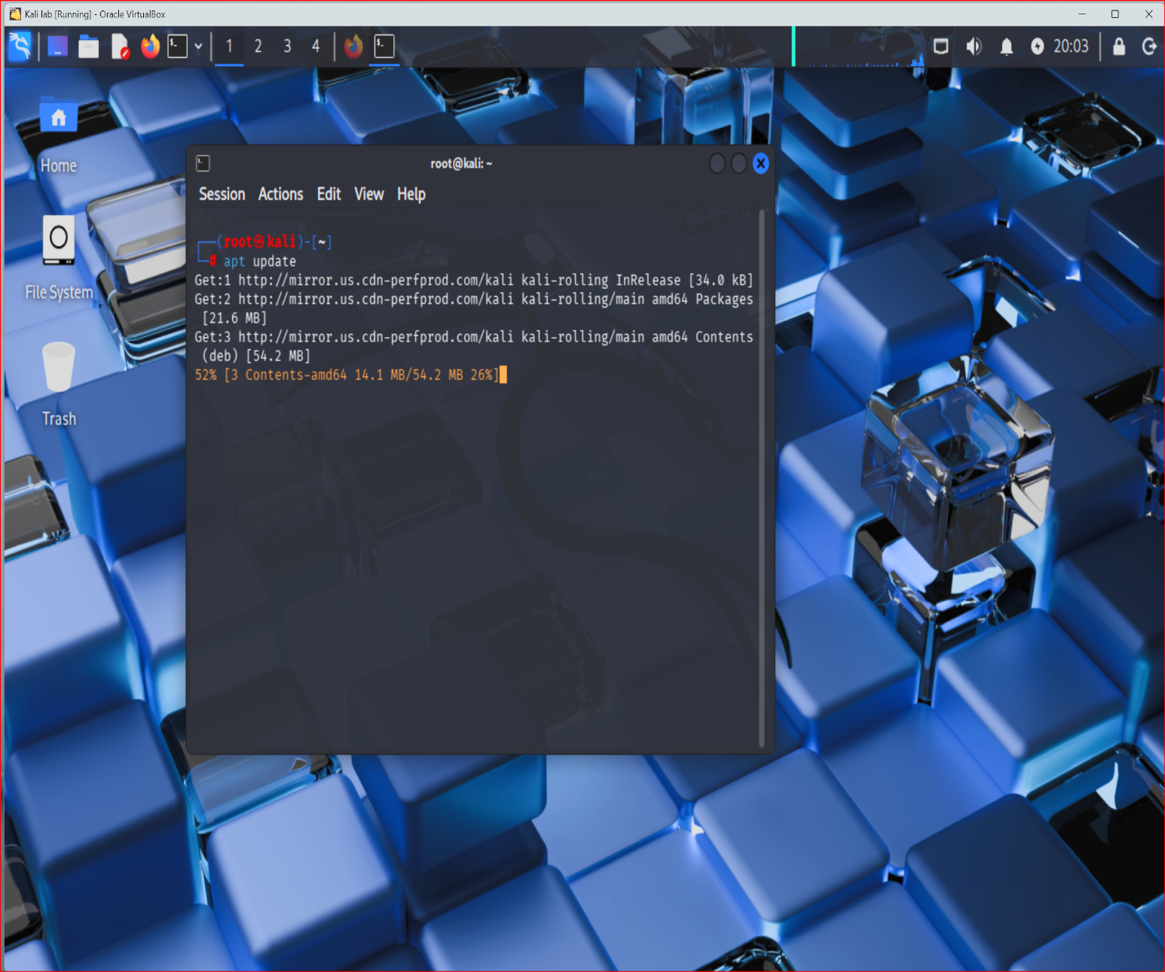
- Install NetExec using the Kali package manager:
-- sudo apt install netexec -y
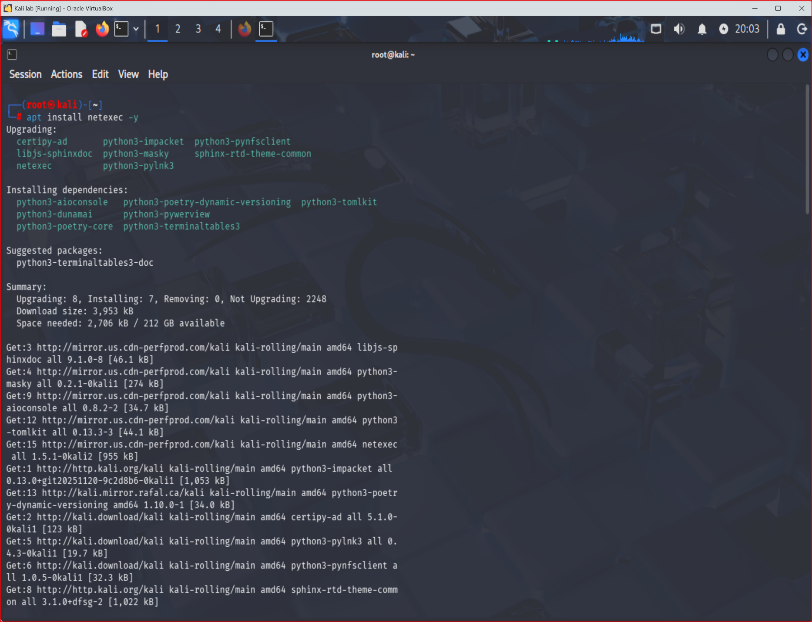
- Verify the installation:
-- nxc –version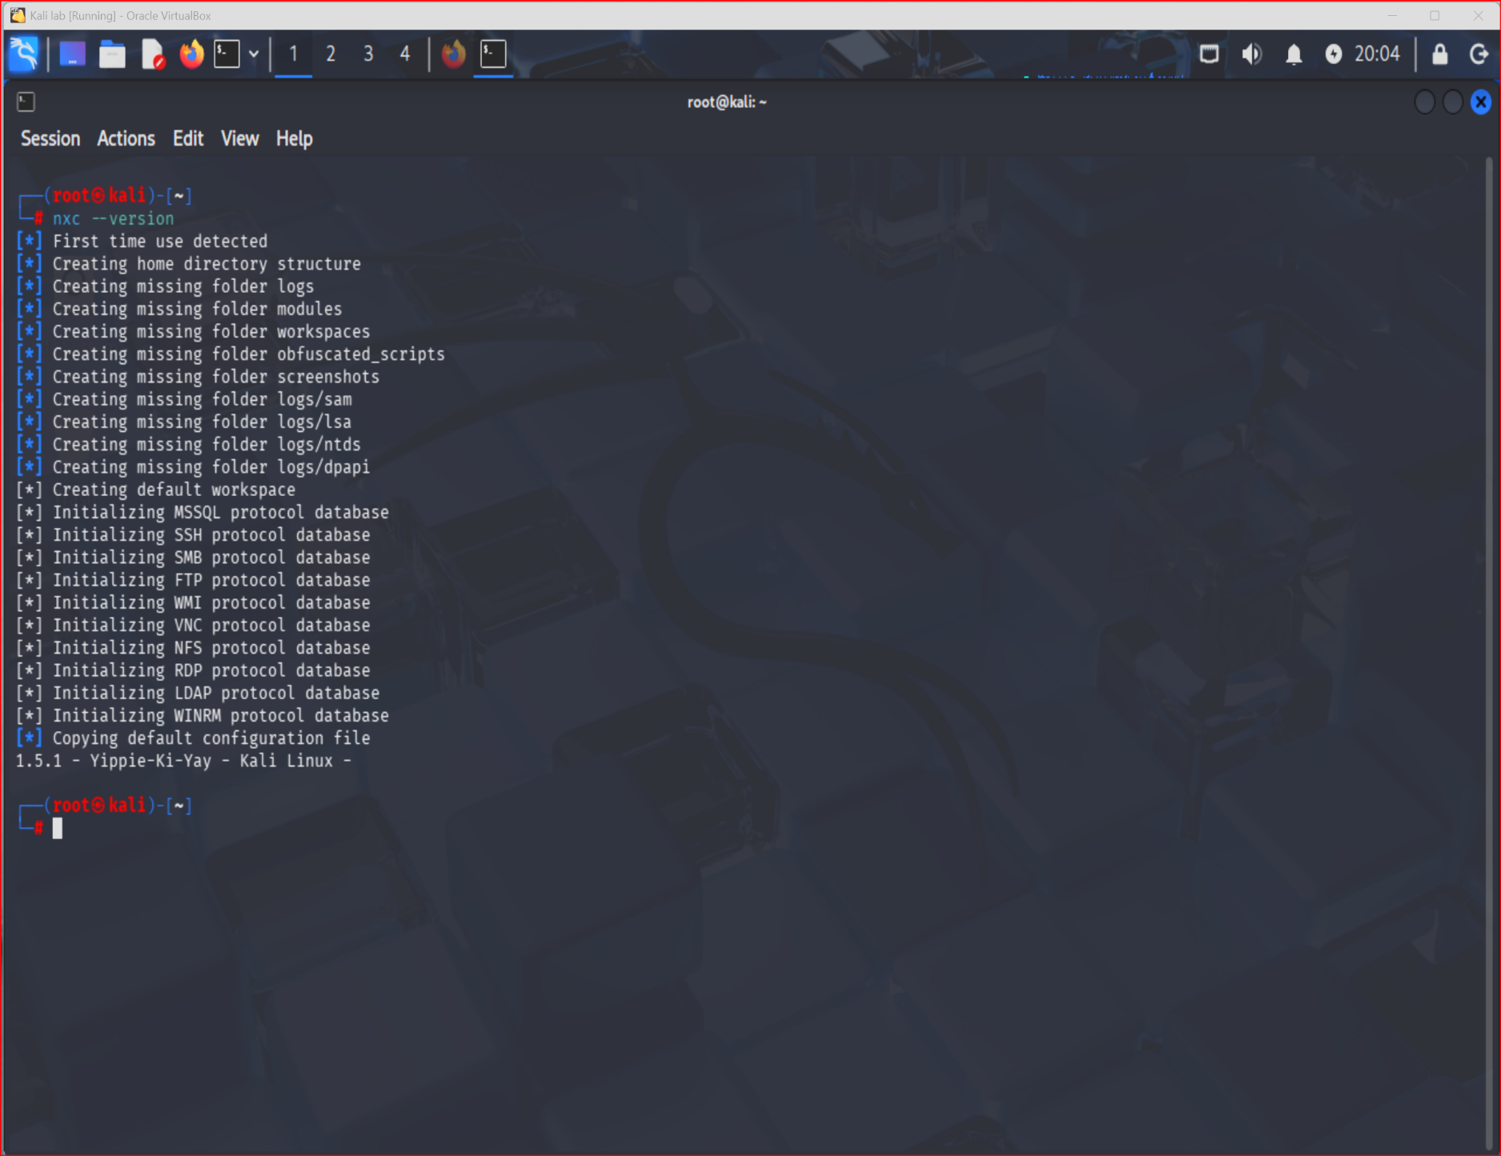
Initial Configuration
When NetExec starts for the first time, it creates its required folders and initializes its configuration and protocol databases. My screenshot shows these setup messages and version 1.5.1.
Usage Guide
Function 1: Viewing General Help
- Open the Kali Linux terminal.
- Enter nxc -h.
- Press Enter.
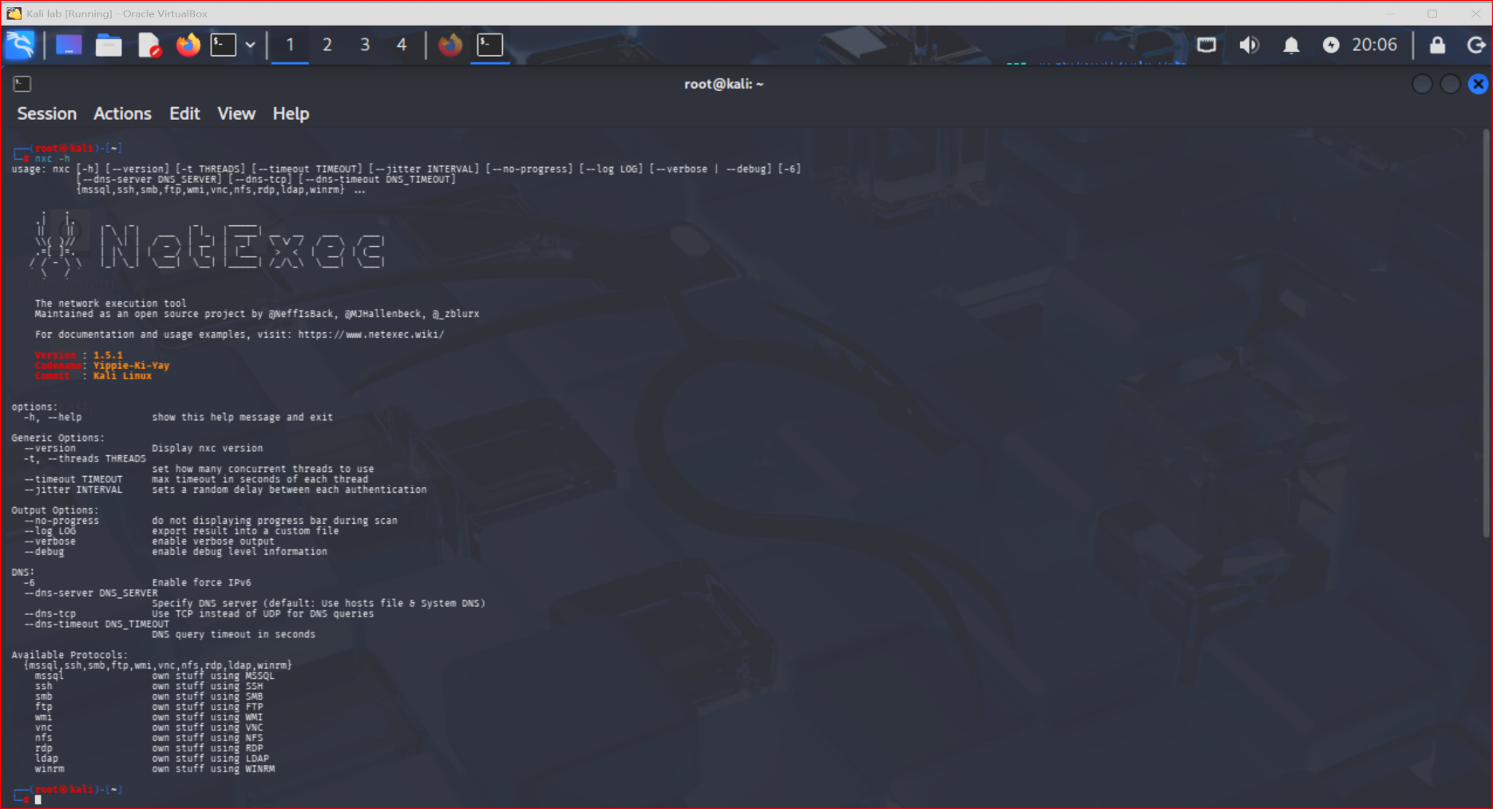
- Review the available options, supported protocols, and usage instructions.
Expected Result: NetExec displays its command-line options and supported network services. This helps users understand the tool before running a security assessment.
Function 2: Reviewing SMB Options
- Enter nxc smb -h in the terminal.
- Press Enter.
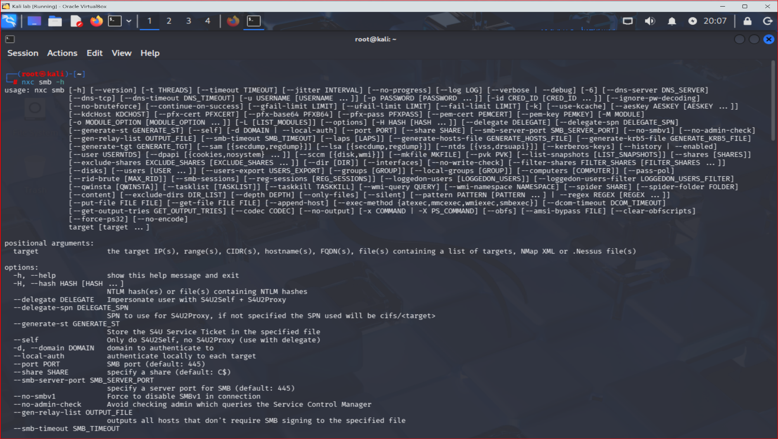
- Review the available SMB options.
- Identify the options relevant to an authorized Windows network assessment.
Expected Result: NetExec displays options for its SMB module, including target information and authentication-related settings.
These display how to use NetExec’s help information. They do not show a scan of a target system.
Common Errors and Troubleshooting
- Command not found: Check that NetExec installed correctly.
- Installation fails: Check your internet connection and package sources.
- Permission error: Check your user permissions.
- Unexpected output: Review the command syntax and built-in help information.
Best Practices
- Ethical considerations: Only test systems you own or have explicit permission to assess. Never attempt to access accounts or systems without authorization.
- Security considerations: Avoid repeated authentication attempts that could lock accounts. Protect credentials and assessment results and use an isolated lab whenever possible.
- Professional recommendations: Learn the available options before performing tests, document your results, and report security weaknesses responsibly. Always confirm that the testing plan is approved before assessing a real network.
References
- NetExec official GitHub repository: https://github.com/Pennyw0rth/NetExec
- NetExec official documentation: https://www.netexec.wiki/
- Kali Linux documentation: https://www.kali.org/docs/
- BloodHound official GitHub repository: https://github.com/SpecterOps/BloodHound
- Impacket official GitHub repository: https://github.com/fortra/impacket
- Responder official GitHub repository: https://github.com/lgandx/Responder
- Mimikatz official GitHub repository: https://github.com/gentilkiwi/mimikatz
- Hashcat official website: https://hashcat.net/hashcat/
- Metasploit Framework official GitHub repository: https://github.com/rapid7/metasploit-framework
- PsExec official Microsoft download page: https://learn.microsoft.com/en-us/sysinternals/downloads/psexec
- mitm6 official GitHub repository: https://github.com/dirkjanm/mitm6
- Sublist3r official GitHub repository: https://github.com/aboul3la/Sublist3r

